Capstone project: Restaurants in Chicago area

Chrisnelle McCanna
April,2020

I- Introduction:

The City of Chicago covers an area of 60,000 hectares and sits 176 meters (578 feet) above sea level on the southwestern shore of Lake Michigan. At 190 km wide and 495 km long, its the 5th largest body of fresh water in the world. The city is traversed by the Chicago and Calumet rivers. Chicago's extensive parkland, including 3,000 hectares of city parks attract an estimated 86 million visitors annually.
As a multicultural city that thrives on the harmony and diversity of its neighborhoods, Chicago today embodies the values of America's heartland-integrity, hard work and community and reflects the ideals in the social fabric of its 77 distinct neighborhoods.
Chicago is recognized across the United States as a very passionate sports town.
Chicago is a leader in reforming public schools, enhancing public safety and security initiatives, providing affordable housing in attractive and economically sound communities, ensuring accessibility for all and fostering, social, economic and environmental sustainability.

I-2 Problem:

find a less dangerous place to create a restaurant in Chicago

We get these questions all the time from potential Chicago business partner : Is this neighborhood safe? What are the safest neighborhoods? And then plenty of people just want to know for the heck of it which neighborhoods are the most dangerous. I assume they're just curious and not really interested to create a restaurant to those dangerous neigh .The problem is that it's certainly not possible to give our stamp of approval to any particular neighborhood. There are few absolutes in this world and "safe" and "dangerous" are not among them. And even relative comparisons are difficult except at the extremes
3- Project Idea

My idea for the Capstone Project is to show that when driven by venue and location data from Foursquare, backed up with open source crime data, that it is possible to present the cautious and nervous traveler with a list of attractions to visit supplements with a graphics showing the occurrence of crime in the region of the venue.

A high level approach is as follows:

- The travelers decides on a city location [in this case Chicago
- The Foursquare website is scrapped for the top venues in the city
- From this list of top venues the list is augmented with additional geographical data
- Using this additional geographical data the top nearby restaurants are selects
- The historical crime within a predetermined distance of all venues are obtained
- A map is presented to the to the traveler showing the selected venues and crime statistics of the area.
The future probability of a crime happening near or around the selected top sites is also presented to the user
Solution target:

This solution is targeted at the cautious traveler The want to see all the main sites of a city that they have never visited before but at the same time, for whatever reasons unknown, they want to be able to do all that they can to make sure that they stay clear of trouble, is it safe to visit this venue and this restaurant at 4:00 pm in the afternoon.

Some examples of envisioned users include:

A single white female traveler
An elderly traveler that has had previous back experiences when traveling
There are many data science aspect of this project including:

Data Acquisition
Data Cleansing
Data Analysis
Machine Learning
Prediction

Now that the conference is over the Data Scientist can explore Chicago and feel much safer.

4- Data Description:

In this section, I will describe the data used to solve the problem as described previously.

As noted below in the Further Development Section, it is possible to attempt quite complex and sophisticated scenarios when approaching this problem. However, given the size of the project and for simplicity only the following scenario will be addressed:

Query the Foursquare website for the top sites in Chicago
Use the Foursquare API to get supplemental geographical data about the top sites
Use the Foursquare API to get top restaurant recommendations closest to each of the top site
Use open source Chicago Crime data to provide the user with additional crime data

5- Import Libraries:

In this section we import the libraries that will be required to process the data.

The first library is Pandas.

Pandas is an open source, BSD-licensed library, providing high-performance, easy-to-use data structures and data analysis tools for the Python programming language.

In this section we import the libraries that will be required to process the data.

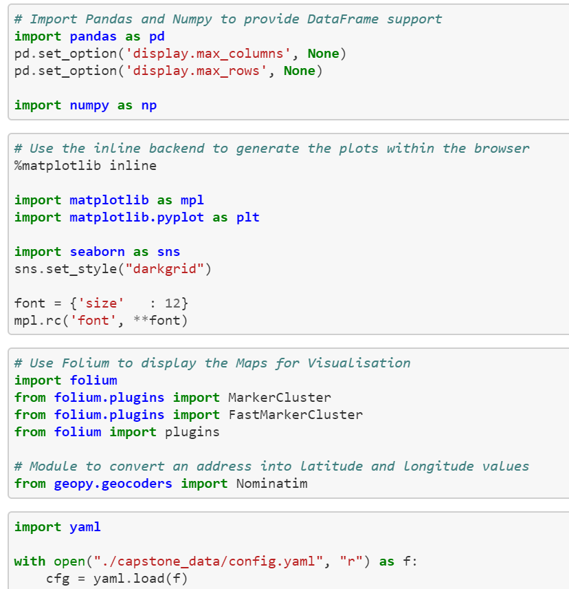

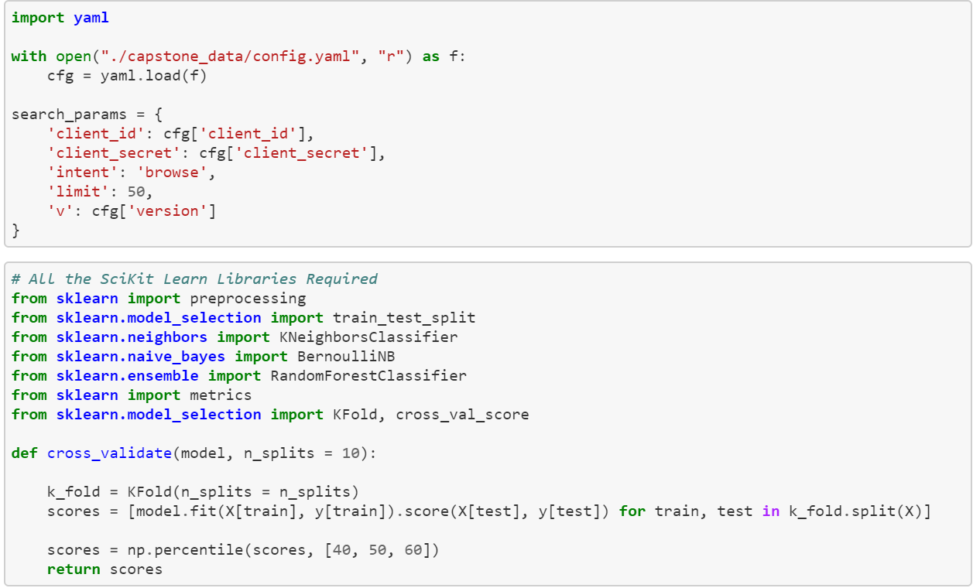

Data Visualization:

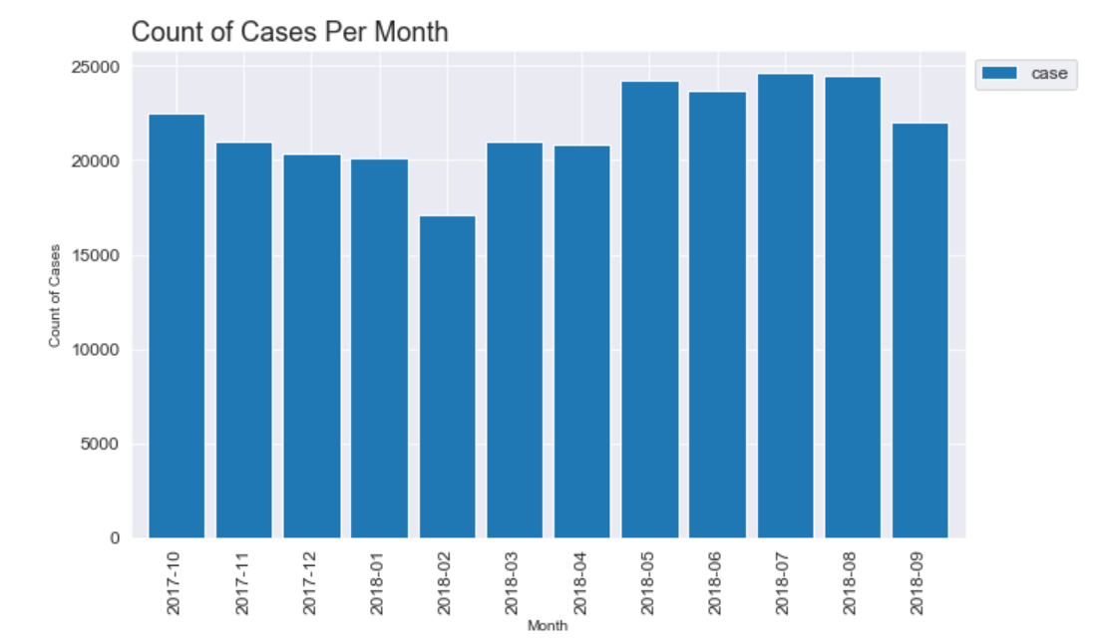
Number of crimes occurring on each day:

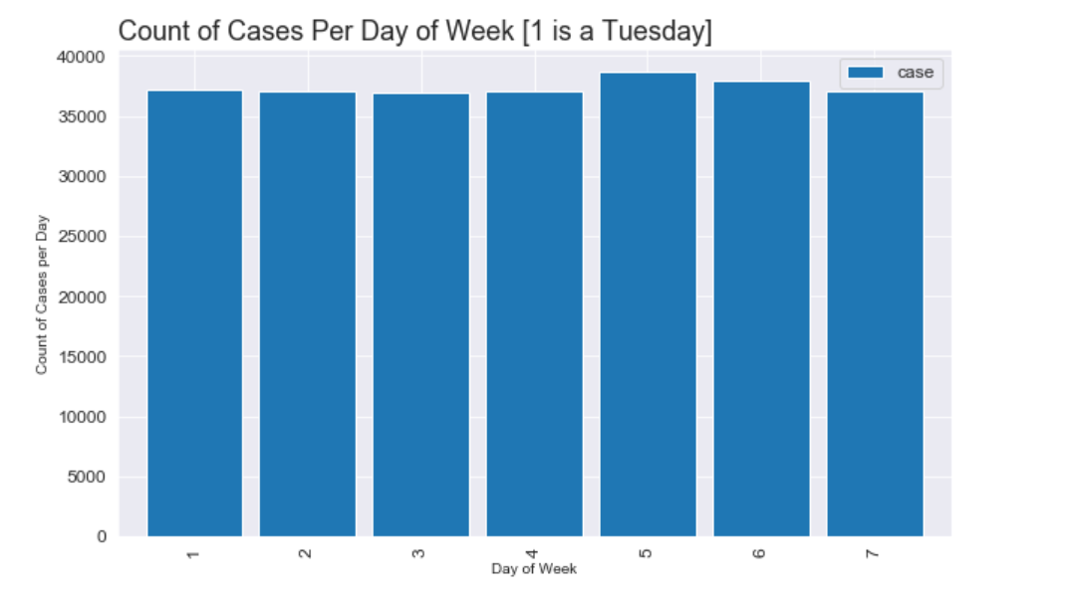

Number of crimes occurring in each hour:

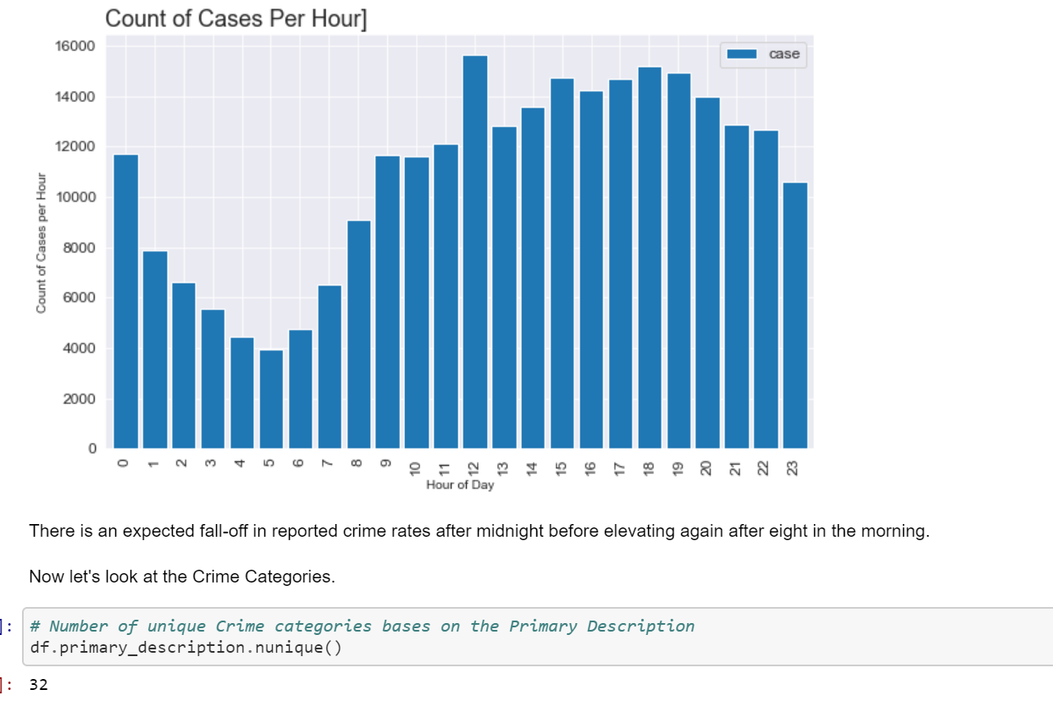

So let's look at murder by neighborhood first - well, actually, by community area. You can click on graph below and it will expand to a more legible size. In order to normalize for the populations of the community areas I calculated a murder rate per 100,000 people and then sorted the community areas from lowest murder rate to highest
Crime Categories:

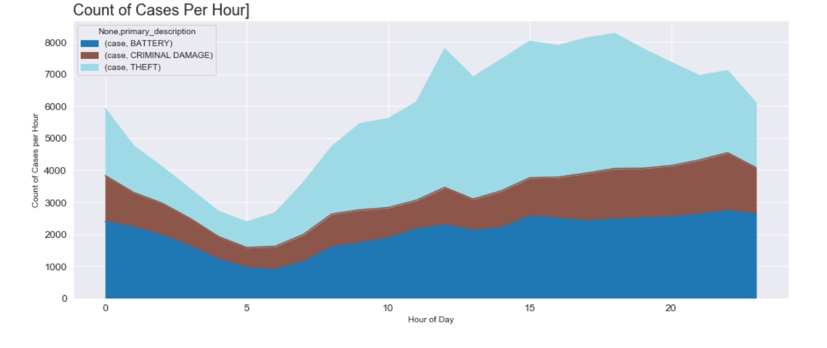
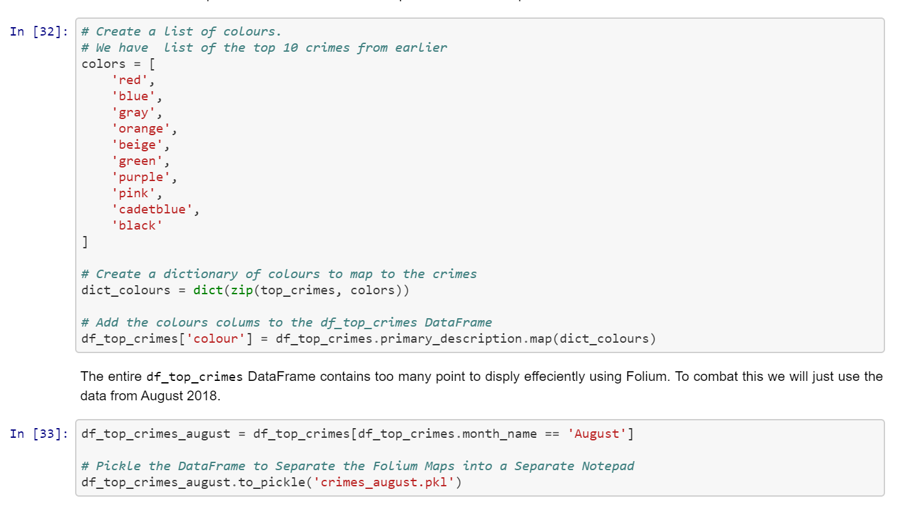

Geo-location coordinates:

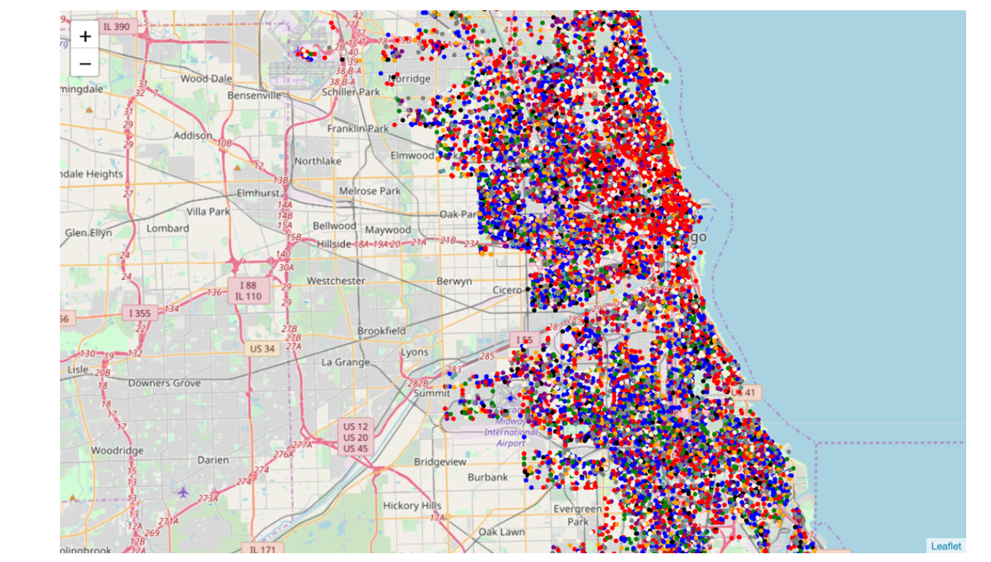
Chicago_cluster:

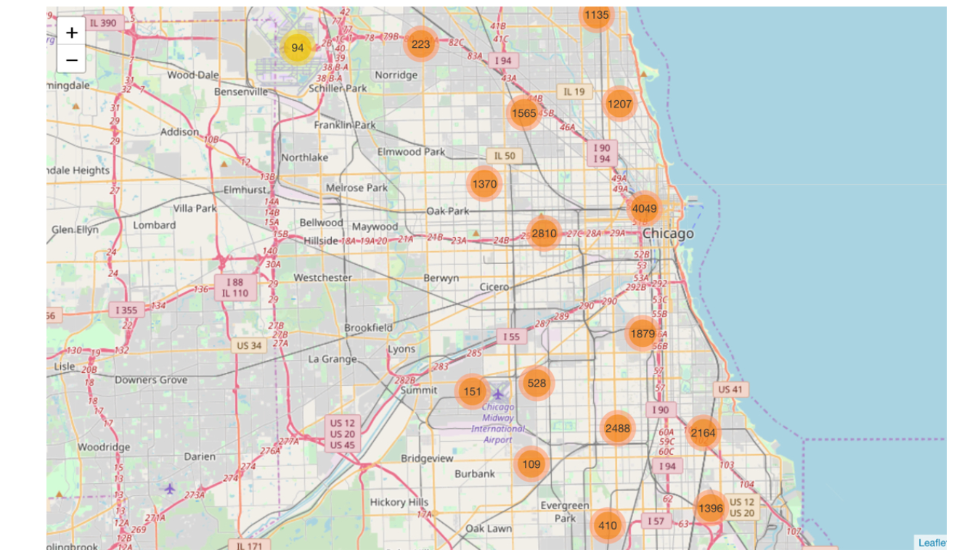

Chicago_heat mat
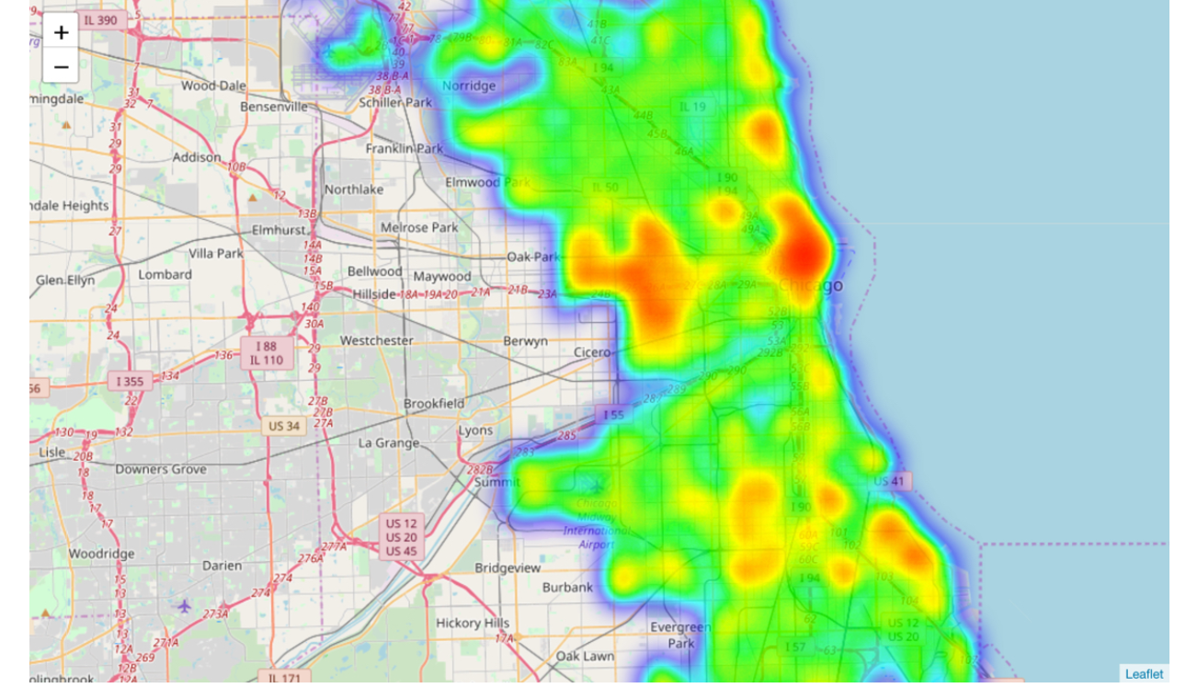

K Nearest Neighbor(KNN):

The graph below shows the number of people killed in Chicago by month and, as you can see, there is a strong seasonal pattern. Apparently the heat really puts some people in a bad mood. Or maybe it's really uncomfortable holding a cold metal gun. Anyway, that's why there is a red 12 month moving average line in the graph also - to smooth out the seasonal pattern and allow us to see the overall trend.
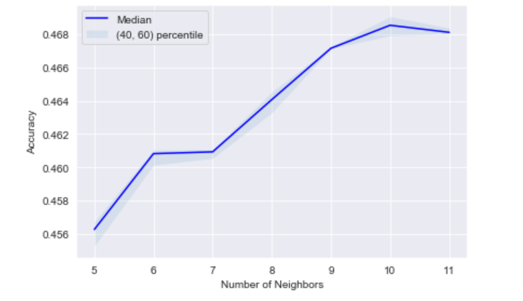

Conclusion:

the Chicago area is the must dangerous place to create a business with real estate brokerage that offers rebates and discount commissions. It is important to keep up to date on the Chicago real estate market or get an insider's view of the seamy underbelly of the real estate industry.

Thank you!

